Introduction to Computer Security and Cryptography
Classical Encryption Techniques
Symmetric encryption, also referred to as conventional encryption or single-key encryption, was the only type of encryption in use prior to the development of public-key encryption in the 1970s. It remains by far the most widely used of the two types of encryption.
Before beginning, we define some terms. An original message is known as the plaintext, while the coded message is called the ciphertext. The process of converting from plaintext to ciphertext is known as enciphering or encryption; restoring the plaintext from the ciphertext is deciphering or decryption. The many schemes used for encryption constitute the area of study known as cryptography. Such a scheme is known as a cryptographic system or a cipher. Techniques used for deciphering a message without any knowledge of the enciphering details fall into the area of cryptanalysis. Cryptanalysis is what the layperson calls “breaking the code.” The areas of cryptography and cryptanalysis together are called cryptology.
- Symmetric Cipher Model
A symmetric encryption scheme has five ingredients (Figure 1):
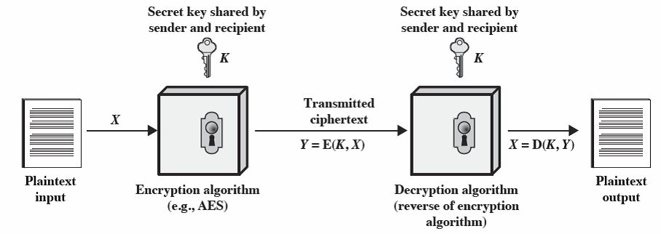
Figure 1. Simplified Model of Symmetric Encryption
- Plaintext: This is the original intelligible message or data that is fed into the algorithm as input.
- Encryption algorithm: The encryption algorithm performs various substitutions and transformations on the plaintext.
- Secret key: The secret key is also input to the encryption algorithm. The key is a value independent of the plaintext and of the algorithm. The algorithm will produce a different output depending on the specific key being used at the time. The exact substitutions and transformations performed by the algorithm depend on the key.
- Ciphertext: This is the scrambled message produced as output. It depends on the plaintext and the secret key. For a given message, two different keys will produce two different ciphertexts. The ciphertext is an apparently random stream of data and, as it stands, is unintelligible.
- Decryption algorithm: This is essentially the encryption algorithm run in reverse. It takes the ciphertext and the secret key and produces the original plaintext.
There are two requirements for secure use of conventional encryption:
- We need a strong encryption algorithm. At a minimum, we would like the algorithm to be such that an opponent who knows the algorithm and has access to one or more ciphertexts would be unable to decipher the ciphertext or figure out the key. This requirement is usually stated in a stronger form: The opponent should be unable to decrypt ciphertext or discover the key even if he or she is in possession of a number of ciphertexts together with the plain-text that produced each ciphertext.
- Sender and receiver must have obtained copies of the secret key in a secure fashion and must keep the key secure. If someone can discover the key and knows the algorithm, all communication using this key is readable.
We assume that it is impractical to decrypt a message on the basis of the ciphertext plus knowledge of the encryption/decryption algorithm. In other words, we do not need to keep the algorithm secret; we need to keep only the key secret. This feature of symmetric encryption is what makes it feasible for widespread use.
- Cryptography
Cryptographic systems are characterized along three independent dimensions:
- The type of operations used for transforming plaintext to ciphertext. All encryption algorithms are based on two general principles: substitution, in which each element in the plaintext (bit, letter, group of bits or letters) is mapped into another element, and transposition, in which elements in the plaintext are rearranged. The fundamental requirement is that no information be lost (i.e., that all operations are reversible). Most systems, referred to as product systems, involve multiple stages of substitutions and transpositions.
- The number of keys used. If both sender and receiver use the same key, the system is referred to as symmetric, single-key, secret-key, or conventional encryption. If the sender and receiver use different keys, the system is referred to as asymmetric, two-key, or public-key encryption.
- The way in which the plaintext is processed. A block cipher processes the input one block of elements at a time, producing an output block for each input block. A stream cipher processes the input elements continuously, producing output one element at a time, as it goes along.
- Cryptanalysis and Brute-Force Attack
Typically, the objective of attacking an encryption system is to recover the key in use rather than simply to recover the plaintext of a single ciphertext. There are two general approaches to attacking a conventional encryption scheme:
- Cryptanalysis: Cryptanalytic attacks rely on the nature of the algorithm plus perhaps some knowledge of the general characteristics of the plaintext or even some sample plaintext–ciphertext pairs. This type of attack exploits the characteristics of the algorithm to attempt to deduce a specific plaintext or to deduce the key being used.
- Brute-force attack: The attacker tries every possible key on a piece of cipher-text until an intelligible translation into plaintext is obtained. On average, half of all possible keys must be tried to achieve success.
If either type of attack succeeds in deducing the key, the effect is catastrophic: All future and past messages encrypted with that key are compromised.
- Substitution Techniques
We now examine a sampling of what might be called classical encryption techniques. A study of these techniques enables us to illustrate the basic approaches to symmetric encryption used today and the types of cryptanalytic attacks that must be anticipated.
The two basic building blocks of all encryption techniques are substitution and transposition. A substitution technique is one in which the letters of plaintext are replaced by other letters or by numbers or symbols. If the plaintext is viewed as a sequence of bits, then substitution involves replacing plaintext bit patterns with ciphertext bit patterns.
Caesar Cipher
The earliest known, and the simplest, use of a substitution cipher was by Julius Caesar. The Caesar cipher involves replacing each letter of the alphabet with the letter standing three places further down the alphabet. For example:
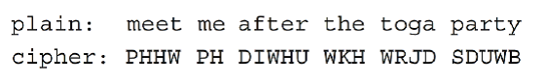
Note that the alphabet is wrapped around, so that the letter following Z is A. We can define the transformation by listing all possibilities, as follows:
If it is known that a given ciphertext is a Caesar cipher, then a brute-force cryptanalysis is easily performed: simply try all the 25 possible keys. Figure 2 shows the results of applying this strategy to the example ciphertext. In this case, the plaintext leaps out as occupying the third line.
Three important characteristics of this problem enabled us to use a brute-force cryptanalysis:
1. The encryption and decryption algorithms are known.
2. There are only 25 keys to try.
3. The language of the plaintext is known and easily recognizable.
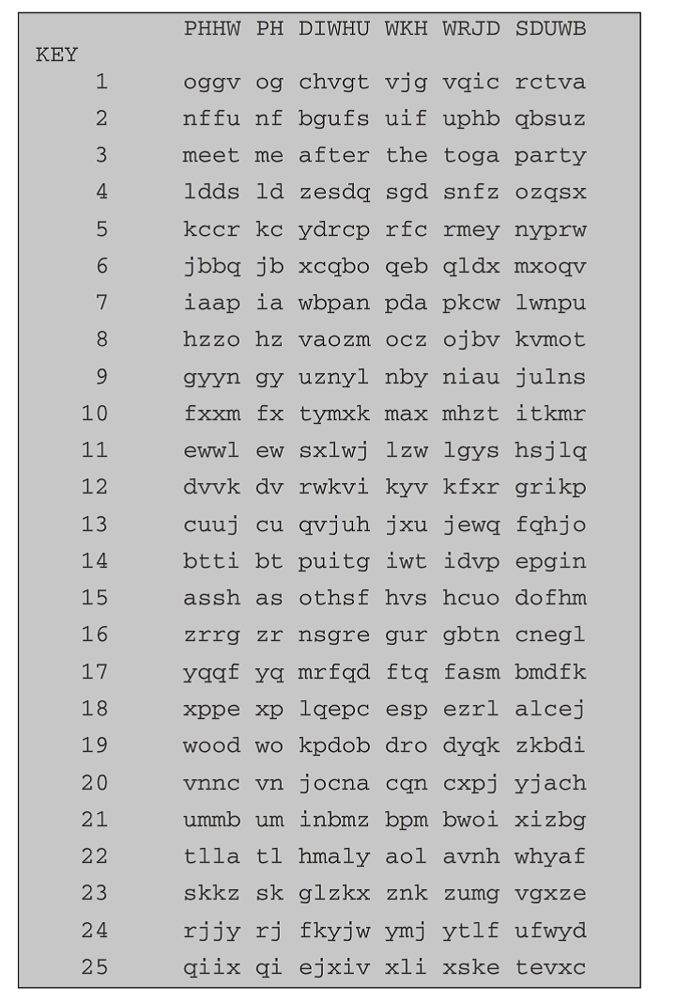
Figure 2 Brute-Force Cryptanalysis of Caesar Cipher

Playfair Cipher
The best-known multiple-letter encryption cipher is the Playfair, which treats digrams in the plaintext as single units and translates these units into ciphertext digrams.The Playfair algorithm is based on the use of a 5 * 5 matrix of letters constructed using a keyword. Here is an example, solved by Lord Peter Wimsey in Dorothy Sayers’s Have His Carcase:

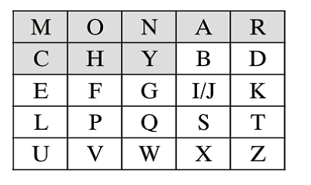
In this case, the keyword is monarchy. The matrix is constructed by filling in the letters of the keyword (minus duplicates) from left to right and from top to bottom, and then filling in the remainder of the matrix with the remaining letters in alphabetical order. The letters I and J count as one letter. Plaintext is encrypted two letters at a time, according to the following rules:
- Repeating plaintext letters that are in the same pair are separated with a filler letter, such as x, so that balloon would be treated as ba lx lo on.
- Two plaintext letters that fall in the same row of the matrix are each replaced by the letter to the right, with the first element of the row circularly following the last. For example, ar is encrypted as RM.
- Two plaintext letters that fall in the same column are each replaced by the letter beneath, with the top element of the column circularly following the last. For example, mu is encrypted as CM.
Otherwise, each plaintext letter in a pair is replaced by the letter that lies in its own row and the column occupied by the other plaintext letter. Thus, hs becomes BP and ea becomes IM (or JM, as the encipherer wishes).
The Playfair cipher is a great advance over simple monoalphabetic ciphers. For one thing, whereas there are only 26 letters, there are 26 * 26 = 676 digrams, so that identification of individual digrams is more difficult. Furthermore, the relative frequencies of individual letters exhibit a much greater range than that of digrams, making frequency analysis much more difficult. For these reasons, the Playfair cipher was for a long time considered unbreakable. It was used as the standard field system by the British Army in World War I and still enjoyed considerable use by the U.S. Army and other Allied forces during World War II.
- Transposition techniques
A very different kind of mapping is achieved by performing some sort of permutation on the plaintext letters. This technique is referred to as a transposition cipher.
The simplest such cipher is the rail fence technique, in which the plaintext is written down as a sequence of diagonals and then read off as a sequence of rows. For example, to encipher the message “meet me after the toga party” with a rail fence of depth 2, we write the following:

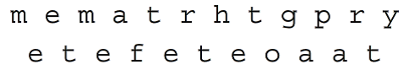
The encrypted message is
MEMATRHTGPRYETEFETEOAAT
This sort of thing would be trivial to cryptanalyze. A more complex scheme is to write the message in a rectangle, row by row, and read the message off, column by column, but permute the order of the columns. The order of the columns then becomes the key to the algorithm. For example,
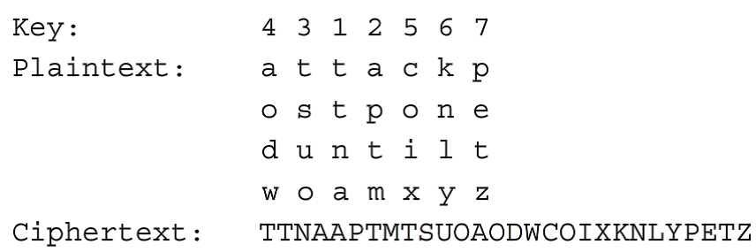
Thus, in this example, the key is 4312567. To encrypt, start with the column that is labeled 1, in this case column 3. Write down all the letters in that column. Proceed to column 4, which is labeled 2, then column 2, then column 1, then columns 5, 6, and 7.
A pure transposition cipher is easily recognized because it has the same letter frequencies as the original plaintext. For the type of columnar transposition just shown, cryptanalysis is fairly straightforward and involves laying out the ciphertext in a matrix and playing around with column positions. Digram and trigram frequency tables can be useful. The transposition cipher can be made significantly more secure by performing more than one stage of transposition. The result is a more complex permutation that is not easily reconstructed.
To learn more about classical encryption techniques, check the following sites:
- Introduction to Cryptography - Caesar Cipher
https://www.youtube.com/watch?v=pIt4Q68J00A
- Cryptography - Caesar Cipher - Theory and Implementation
https://www.youtube.com/watch?v=LVHeW1hcdRk
- Caesar Cipher
https://www.youtube.com/watch?v=o6TPx1Co_wg
- Caesar cipher
http://en.wikipedia.org/wiki/Caesar_cipher
- Playfair Cipher Explained
https://www.youtube.com/watch?v=quKhvu2tPy8
- Playfair Cipher
https://www.youtube.com/watch?v=3c1PE5vPSRo
- Playfair cipher
http://en.wikipedia.org/wiki/Playfair_cipher
- Rail Fence Cipher
https://www.youtube.com/watch?v=qOlJwi9mu2Q
- Cipher Challenge: Rail Fence
https://www.youtube.com/watch?v=5xVbWnhOIxY
- Rail fence cipher
http://en.wikipedia.org/wiki/Rail_fence_cipher

SLP Assignment
- Construct a Playfair matrix with the key largest.
- Construct a Playfair matrix with the key occurrence.
- Using this Playfair matrix:
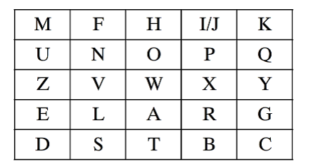
Encrypt this message:
Must see you over Cadogan West Coming at once

SLP Assignment Expectations
Use information from the modular background readings as well as the given resources. Also, you could use any good quality resource you can find. Please cite all sources and provide a reference list at the end of your paper.
Length: 1-2 pages (excluding the title page and reference pages) and double-spaced.
The following items will be assessed in particular:
- Your ability to consolidate ideas from reading materials and your understanding of the materials.
- Your ability to write a report with strong argument.
- Some in-text references to modular background readings.

